Lab0
Name : Yamin Yee
Date : Sep 2, 2019
Lab Assignment : #00 - The Complex Plane
clear all; close all; clc; format compact;
disp('Lab #0 -- The Complex Plane');
disp(' ');
disp('%%%% Yamin Yee %%%%');
disp('%%%% CECS 463 Fall 2019 %%%%');
disp('%%%% Lab Assignment #00 %%%%');
disp('%%%% 9/4/2019 %%%%');
disp(' ');
str=datestr(now); disp(['Matlab Time Stamp: ',str]);
Lab #0 -- The Complex Plane
%%%% Yamin Yee %%%%
%%%% CECS 463 Fall 2019 %%%%
%%%% Lab Assignment #00 %%%%
%%%% 9/4/2019 %%%%
Matlab Time Stamp: 04-Sep-2019 14:32:01

Problem 1
disp('Problem 1');
Amax=0.75; Amin=-2.75; A0=-2.5; dT=0.018;
DC_Offset = (Amax + Amin)/2;
disp([' DC_Offset = ', num2str(DC_Offset)]);
% Alternatively: fprintf(' DC_Offset = %6.2f\n', DC_Offset);
A = (Amax-Amin)/2;
disp([' A = ', num2str(A)]);
T=0.04; f=1/T; w=2*pi*f;
disp([' Period T= ',num2str(T),' sec f=1/T = ', num2str(f),'Hz w = 2*pi*f= ', num2str(w), ' r/s']);
phase= acos((A0-DC_Offset)/A) *180/pi; %Ambiguous (+-) result
if abs(A*cos(2*pi*f*(0.017)+phase*pi/180)+DC_Offset-Amax) >= 0.01
phase=-phase; %it is the negative phase angle
end
% Alternatively: phase= -(dT/T)*360;
disp([' Phase = ', num2str(phase),' degrees']);
t=[0:0.001:0.16]; x=A*cos(2*pi*f*t+phase*pi/180)+DC_Offset;
figure(1);
plot(t,x);grid on; title('Figure 1');
xlabel('t (sec)'); ylabel('Amplitude');
disp(' ');
Problem 1
DC_Offset = -1
A = 1.75
Period T= 0.04 sec f=1/T = 25Hz w = 2*pi*f= 157.0796 r/s
Phase = -148.9973 degrees
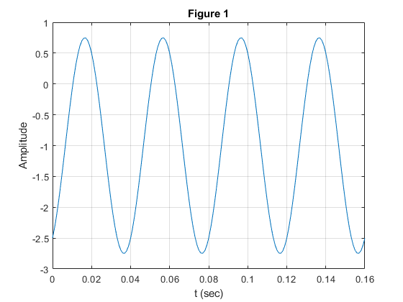

Problem 2a
disp('Problem 2a -- Complex Operations');
x=1.0-2.0j; y=-1.0+1.0j;
a=x+y; b=x-y; c=x*y; d=x/y; p=x^y; %pchk=exp(y*(log(abs(x))+1j*angle(x)));
disp([' x = ', num2str(x)]);
disp([' y = ', num2str(y)]);
disp([' a = x+y = ', num2str(a)]);
disp([' b = x-y = ', num2str(b)]);
disp([' c = x*y = ', num2str(c)]);
disp([' d = x/y = ', num2str(d)]);
disp([' p = x^y = ', num2str(p)]); % pchk=exp(y*(log(abs(x))+1j*angle(x)))
Problem 2a -- Complex Operations
x = 1-2i
y = -1+1i
a = x+y = 0-1i
b = x-y = 2-3i
c = x*y = 1+3i
d = x/y = -1.5+0.5i
p = x^y = -0.45262+1.2752i

Problem 2b
disp('Problem 2b --Sinusoid Plots (see Figure 2)');
figure(2);
hold on;
plot(0,0,'k+');
plot(real(x),imag(x),'*b')
plot(real(y),imag(y),'*r')
plot(real(a),imag(a),'*g')
plot(real(b),imag(b),'*k')
plot(real(c),imag(c),'*y')
plot(real(d),imag(d),'*m')
plot(real(p),imag(p),'*c')
axis([-5 5 -5 5]); grid on;
Problem 2b --Sinusoid Plots (see Figure 2)
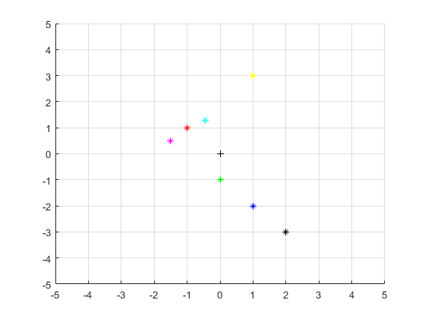

Problem 2c
disp('Problem 2c -- Complex Points as Vectors (see Figure 3)');
xMag=abs(x); xPh=angle(x)*180/pi;
yMag=abs(y); yPh=angle(y)*180/pi;
aMag=abs(a); aPh=angle(a)*180/pi;
bMag=abs(b); bPh=angle(b)*180/pi;
cMag=abs(c); cPh=angle(c)*180/pi;
dMag=abs(d); dPh=angle(d)*180/pi;
pMag=abs(p); pPh=angle(p)*180/pi;
disp([' xMag = ', num2str(xMag,3), ' xPh = ', num2str(xPh,3), ' degrees']);
disp([' yMag = ', num2str(yMag,3), ' yPh = ', num2str(yPh,3), ' degrees']);
disp([' aMag = ', num2str(aMag,3), ' aPh = ', num2str(aPh,3), ' degrees']);
disp([' bMag = ', num2str(bMag,3), ' bPh = ', num2str(bPh,3), ' degrees']);
disp([' cMag = ', num2str(cMag,3), ' cPh = ', num2str(aPh,3), ' degrees']);
disp([' dMag = ', num2str(dMag,3), ' dPh = ', num2str(bPh,3), ' degrees']);
disp([' pMag = ', num2str(pMag,3), ' pPh = ', num2str(pPh,3), ' degrees']);
plot(0,0,'k+');
plot([0,real(x)],[0,imag(x)],'b-')
plot([0,real(y)],[0,imag(y)],'r-')
plot([0,real(a)],[0,imag(a)],'g-')
plot([0,real(b)],[0,imag(b)],'k-')
plot([0,real(c)],[0,imag(c)],'y-')
plot([0,real(d)],[0,imag(d)],'m-')
plot([0,real(p)],[0,imag(p)],'c-')
title('Figure 2'); xlabel('REAL'); ylabel('IMAGINARY');
legend('Origin','x','y','x+y','x-y','x*y','x/y','x^y');
hold off;
disp(' ');
Problem 2c -- Complex Points as Vectors (see Figure 3)
xMag = 2.24 xPh = -63.4 degrees
yMag = 1.41 yPh = 135 degrees
aMag = 1 aPh = -90 degrees
bMag = 3.61 bPh = -56.3 degrees
cMag = 3.16 cPh = -90 degrees
dMag = 1.58 dPh = -56.3 degrees
pMag = 1.35 pPh = 110 degrees
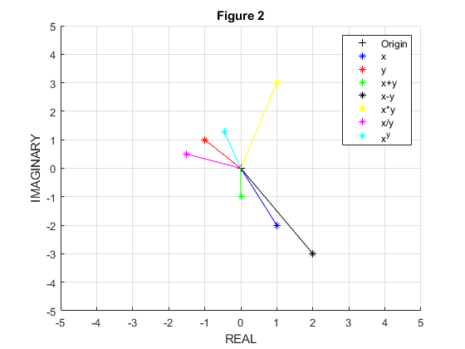

Problem 3
disp('Problem 3 -- Phasors (see Figure 3)');
figure(3);
hold on;
plot(0,0,'k+');
axis([-5 5 -5 5]); grid on;
title('Figure 3'); xlabel('REAL'); ylabel('IMAGINARY');
X=3*exp(1j*45*pi/180); Y=2*exp(1j*(-150-90)*pi/180); Z=X+Y;
Xm=abs(X); Xph=angle(X); Ym=abs(Y); Yph=angle(Y);Zm=abs(Z); Zph=angle(Z);
hold on;
arrow([0,0],[real(X),imag(X)],'Color','b','BaseAngle',60);text(real(X),imag(X)+0.1,' X Phasor');
arrow([0,0],[real(Y),imag(Y)],'Color','r','BaseAngle',60);text(real(Y),imag(Y)+0.1,' Y Phasor');
arrow([0,0],[real(Z),imag(Z)],'Color','g','BaseAngle',60);text(real(Z),imag(Z)+0.1,' X+Y Phasor');
disp([' Z=X+Y: Zmag=', num2str(Zm),' Zph=', num2str(Zph*180/pi)]);
t=[0:1000]*2*pi/1000;
x=3*cos(25*t+45*pi/180); y=2*sin(25*t-150*pi/180); z=x+y;
figure(4);
hold on;
plot(t,x,'b'); plot(t,y,'r'); plot(t,z,'g')
axis([0 0.8 -5 5]); grid on;
title('Figure 4');
xlabel('t (sec)'); ylabel('Amplitude');
legend('x(t)','y(t)','z(t)=x(t)+y(t)');
%tilefigs;
Problem 3 -- Phasors (see Figure 3)
Z=X+Y: Zmag=4.0132 Zph=73.7752
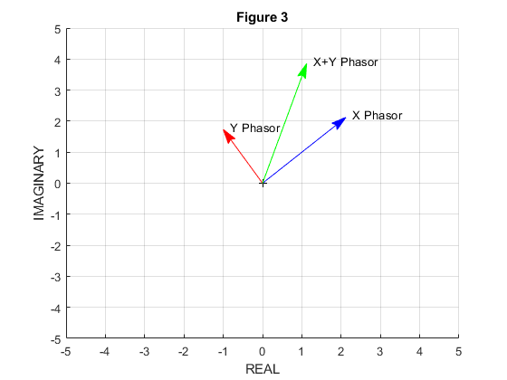
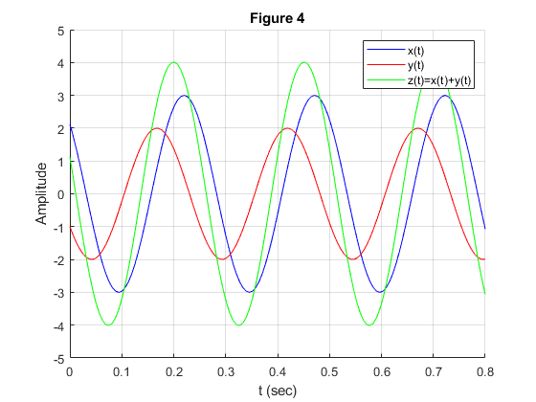
Published with MATLAB® R2019a

